Home > U.S. News
Opinion

What It's Like Being Another Kind of Black Jew

Avi Shafran SendSend me email alerts
Jan 27, 2019 6:01 PM

I’m a black Jew. Despite my Caucasian coloring.
My skin color is what people call white. But the felt fedora I wear in public is black, as are my shoes and, more often than not, my suit.
That clarification isn’t meant as a punchline. Despite my skin color, I experience something of what America's minorities of color experience. I am perceived with suspicion by many, am often on the receiving end of sidelong glances and, occasionally, outright insults. I’ve had pennies thrown at my feet from a car while waiting at a bus stop and, on public transportation, been greeted with a hail of "Heil Hitlers."
Orthodox Jews of all color skin have, in a number of places, also been targets of some local politicians’ venting of their inner bigots.
In a recent social media posting on the Rockland County (NY) Republican party’s official page, its leader, Lawrence Garvey, called Orthodoxy "the most egregious example of women’s oppression in our entire country," falsely claiming, inter alia odiosa, that Orthodox women are forced into arranged marriages and aren’t properly educated.
His fellow Rockland County politician, councilman Pete Bradley, had ugliness of his own to display. Seeking to prevent Orthodox families from outside the official border of a town in his district from using its public parks, he offered to "personally conduct the security check" if any upstanding citizens should spy any such offenders.

"Remember," he cautioned his constituents, "while other municipalities are out to smother all of their open space with abhorrent high-density housing, our goal is to ‘Preserve Clarkstown’ and our beautiful parks!"
As Steve Gold, chair of the Community Relations Council of the Jewish Federation & Foundation of Rockland County, noted about the slippery slope of this profiling: "The idea of self-appointed residents who will decide that other people look like they do or do not belong is dangerous and risky…[its message is that the County] only wants people who look like they 'fit in.'"
The same Mr. Bradley last year criticized New York Gov. Andrew Cuomo for visiting with Hasidic Jewish community leaders, contrasting them with what he called "normal Jews."
And just as Americans of color find themselves targets of hateful acts and actual violence, so do haredi Jews.
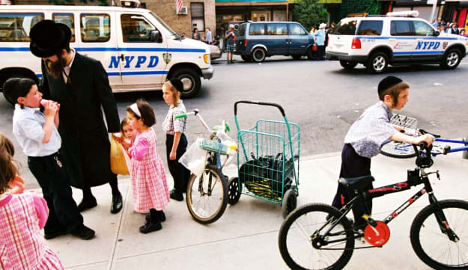The Jewish neighborhood Borough Park in Brooklyn NY.Nir Kafri
In New York City, more than 150 swastika scrawlings have been recorded from 2016 to 2018, including a good number of them on parked cars and walls in heavily-haredi Borough Park, Brooklyn.
Recently, in Brooklyn’s Crown Heights neighborhood, an Orthodox man and an Orthodox woman were recently punched without reason or warning by men within a span of 48 hours.
So, while I would never equate what we haredim experience in America today with the sort of persistent racial prejudice that people of color experience in employment, housing and police encounters, when it comes to expressions of animus, I can, at least to a degree, relate.
In the recent debates that swirled around the Women’s March there was much talk of class and race, of the differing experiences of white Jews and Jews of color, and of Jewish attitudes toward non-Jewish people of color, of Jewish privilege and Jewish vulnerability.
These debates almost entirely ignored even mentioning the experience of immediately-identifiable Orthodox Jews; these kind of debates about identity politics don't have room for us. There is no framework for our victimhood.
What’s more, I and my fellow haredi Jews regularly feel the pinch of more subtle prejudice, too – even, to our chagrin, from fellow Jews.
Take the term "ultra-Orthodox," applied to us by otherwise sensitive-to-the-feelings-of-others people. Living our Judaism like the forebears of most Jews lived theirs may make us haredim a minority, but it shouldn’t place us "beyond the pale of normalcy," which is what "ultra" telegraphs.
Yet, former Forward editor Jane Eisner responded to a public plea from me that the publication stop using the phrase, by claiming it wasn’t pejorative, since "ultra-thin" is a positive selling point for things like condoms - and, besides, haredim are more meticulous, hence religiously radical, in observance than her own grandparents were.
Then there is the sneering we endure from other Jews for our defense of halakhic standards regarding conversion, marriage and divorce in Israel. For maintaining our – historical Judaism’s – principles, we are portrayed as small-minded; for seeking to preserve traditional Jewish norms for public prayer services at the Western Wall, we are condemned as mullahs and women-haters (including, presumably, our wives and daughters); for taking Jewish law and custom seriously, we are sneered at as backward.
Disdain, and worse, for Jews in general is a global phenomenon. Or, more accurately, remains one. Today, though, there is also contempt, and by other members of the tribe, for those of us committed to the Judaism of the ages. We have become what I have often called "the Jews’ Jews."
African American parents speak of "the talk" they feel a need to have with their children, explaining to them the realities of contemporary black life in the U.S. They instruct their young to expect prejudice against them; to not overreact when they encounter it; and how to act, and not act, if accosted by officers of the law.
Responsible haredim have a talk of their own with their kids. We warn them about "bad" neighborhoods – ironically, including some with a significant African American population, since considerable anti-Jewish violence is stoked, unfortunately, by the likes of Louis Farrakhan and some other racist and anti-Semitic rabble-rousers.
And we tell them that, like it or not, they are examples of haredim to all those who see them, and, by exemplifying truly Jewish behavior in public, they can disabuse those around them of any negative images they might harbor about haredim. Of course, that the converse is true, too, and we stress that no less.
Being "black," we tell them, is an opportunity. Even as it remains, because of mindless prejudice, a liability.
Rabbi Avi Shafran is a blogger, a columnist for the American edition of Hamodia, and serves as Agudath Israel of America’s director of public affairs. Twitter: @RabbiAviShafran

Avi Shafran

