Shprintza Genendel, Chani and The Crouton Tree

The unmistakable aroma wafted from the kitchen into Shprintza Genendel’s living room, where she and her best friend Chani were playing a board game. It was called that because it is played on a board. And also because the two girls would quickly grow bored with it. That Friday, the delicious smell didn’t help.
“Chicken soup!” observed Chani, turning toward away from the game to the kitchen and licking her lips with anticipation. Shprintza Genendel agreed with that pronouncement and explained that “Ima always makes chicken, and chicken soup, on erev Shabbos morning.”
“Think she might let us have some now?” Chani asked.
“Sure!” said Shprintza Genendel, knowing her mother well. “But I have to tell you, we’re all out of croutons.”
“No croutons?” Chani said, her voice laden with disappointment. “Chicken soup just isn’t the same without croutons!” Shprintza Genendel solemnly agreed. With seriousness, too.
“Let me ask Ima if she’ll give us some money to go down to Fresser’s Delight to buy some,” suggested Shprintza Genendel. Chani gave her friend a smile and a thumbs-up.
Shprintza Genendel disappeared into the kitchen for a minute and came back holding a five-dollar bill. “Huzzah! Huzzah! Huzzah!” cried Chani. That was Chani’s way of expressing enthusiasm.
Shprintza Genendel and Chani practically danced out the front door, leaving the board and its pieces all over the floor – which elicited a deep sigh from Ima when she came out a few minutes later for a short break from cooking. By then, though, the girls were already marching up and down the aisles at Fresser’s Delight, looking for croutons. When they saw that the shelf where such things belong was bare, their faces fell.
Picking them up, they walked over to the checkout counter to ask the grumpy man standing there if the store had any croutons. “Maybe there are some in the back, somewhere?” asked, and hoped, Shprintza Genendel.
“Nope, sorry,” the checkout man responded dryly. “We sold the last container earlier this morning.”
“Oh, no!” exclaimed Chani. “What will we do?” Shprintza Genendel chimed in.
Mr. Grump-face just looked at the girls, smiled a crooked smile, and said “Why don’t you just go looking for a crouton tree?”
“A crouton tree?” both girls asked incredulously and in unison (and with wonder and at the same time, too). “There’s no such thing as a crouton tree!” Chani added, raising one of her eyebrows (a talent she possessed).
“Why, sure there is, girls. Where do you think WE get the croutons from?”
The girls looked at each other and then at the Mr. Grump-face, then back at each other.
“See that woods behind the store?” he said. “There are crouton trees in it.”
The girls were skeptical (also, they didn’t think he was right). But Shabbos was hours away, and they had nothing better to do, so they set off on a path into the woods.
The birds were singing as they walked. One, a reddish bird with a black tail, landed right in front of them. “Hi bird!” Shprintza Genendel chirped at it.
And do you know what the bird said?
Nothing, of course. Birds can’t talk.
And so the girls continued down the path, with the sun winking through the trees at them, as if to signal to them that they would indeed find a crouton tree on their walk.
But they didn’t. What they did find, though, was a squirrel, standing on a tree branch alongside the path, panting and eyeing them strangely.
“Mr. Squirrel,” Shprintza Genendel said quietly, making Chani smile and roll her eyes. “Would you know where we might find a crouton tree?
The squirrel shook its furry tail, and do you know what it said?
Nothing. Squirrels can’t talk either.
A half-hour later, after passing many different kinds of trees and shrubs but finding nothing that had anything like croutons hanging from it, the girls reached the end of the path, the end of the woods. They were in a neighborhood they didn’t recognize.
“Maybe we should head back the way we came,” said Chani, sensibly.
“Maybe we shouldn’t,” said Shprintza Genendel, non-sensibly.
Chani was about to start arguing with her friend but, as she looked around, she saw that down the street, not 500 feet away from them, stood a food store.
The sign over it read: “Basch’s Noshes.” Shprintza Genendel saw what Chani was looking at and, taking her by the hand, headed straight to the store.
There was a friendly-looking woman behind the counter, and she greeted the girls.
“Hi, ladies, I don’t think I’ve seen you here before.”
“That might be,” Shprintza Genendel offered helpfully, “because we have never been here before!”
Chani chuckled, and told the lady that they were on a quest to find croutons.
“Croutons!?” the lady almost shouted and then broke into a long, loud laugh.
“Yes, croutons!” said Shprintza Genendel.
“Well, my little pretties,” said the lady with a cackle that momentarily alarmed the girls. “You are in luck! You’ve come to the right place.”
She then pranced out from behind the counter and explained. “I ordered one case of croutons last week and the company sent me five cases by accident! I was wondering what I might possibly be able to do with so many containers of croutons! I need my shelf space for other things, like gefilteh fish and breakfast cereal, shoe polish and muffin mix!”
Shprintza Genendel and Chani slowly turned to look at one another, and the same smile seemed to crawl across their faces simultaneously (and at the same time, too).
They turned back to face the lady, who, then disappeared into a back room and returned a moment later with ten containers of croutons!
“All we have is five dollars,” protested Chani.
“No problem. Take them all. I need to unload these croutons. You’ll be doing me a favor by taking them!”
The girls couldn’t believe their good fortune. “Baruch Hashem,” said Chani, and Shprintza Genendel agreed. And before they could properly thank the lady, she had put the containers of croutons into a bag for them. Then they thanked her properly.
Taking turns holding the large bag, which somehow seemed to grow heavier as they walked, the girls headed back along the path they had taken before.
At one point, a dragonfly hovered in front of them, its slender, glistening body shiny blue and its wings beating furiously. “Hi, Mr. Dragonfly!” said Shprintza Genendel. “How are you today?”
And do you know what the dragonfly said?
He said, “Fine, Baruch Hashem. I just ate a tasty mosquito!”
It was a talking dragonfly.
The girls were momentarily taken aback, but it was getting late, so they didn’t carry on the conversation. They wished the dragonfly good luck finding other mosquitos, and hurried on their way.
When they reached the end of the path, they saw that Fresser’s Delight was closing for Shabbos. Mr. Grumpy-face was locking the doors. When he saw the girls, he asked them what they had in their bag. They showed him.
“Where did you get all those croutons?” he asked them.
“Oh,” answered Chani, carefully avoiding saying a lie. “Weren’t you the one who told us about the crouton trees in the woods?”
“Yes!” added Shprintza Genendel, following Chani’s example. “Thank you so much!”
And then the girls turned and headed home, but not before stealing a glance over their shoulders to see Mr. Grumpy-face, headed quickly down the path into the woods.
They giggled all the way home.
P.S : The soup was superb!
(c) 2017 Rabbi Avi Shafran

Meir’s Monster
A short, almost-true story for smart, almost-big children

Meir’s scream, the first time he saw the monster, was extremely loud (for the most part a high-c, though its pitch varied as he wailed), and his parents came rushing in a panic to his room.
It was 2:14 in the morning, and the creature had woken Meir up with growling and grunting noises. He wasn’t furry or fanged, but was terrifying all the same. He had a huge face – in fact, he was mostly face, with no visible body at all, just arms and legs jutting out from where his ears and chin should have been And the face, well, it was a frightful one, with angry eyes – four of them, in fact – and a bulbous, gnarled nose. At the end of the monster’s long, bony hands were clattering claws, which seemed to be reaching for Meir. And the monster’s mouth, which dripped with a mayonnaise-like substance, was slowly opening.
And so, Meir’s scream.
When his parents arrived, the monster promptly disappeared. When they asked Meir, still shaking with fear, what had happened, he couldn’t say a word. His tongue seemed frozen. Truth be told, he had only been speaking intelligibly for a half-year or so, and what speech he managed even in calmer circumstances was rather simple. But even “I saw a monster” eluded him for a full minute, until he managed to squeeze out the words.
“Now, now,” cooed Mother soothingly. “There aren’t any monsters.” Meir wasn’t calmed, though; and now, what was worse, he knew that his mother didn’t know everything after all.
All the same, though, Mother’s embrace and gentle rocking, along with Father’s singing quietly lulled Meir back to sleep in what seemed to be seconds, even though as Mother and Father could tell you, it was really close to an hour.
As fate would have it, the frightful monster showed up with frightful regularity, every night for many nights thereafter, and always at, or around, the same frightful hour. And each night Meir would scream, his parents (at first, both; eventually one or the other) would come, and the monster would, at that very moment, disappear.
Meir was not happy. How do I get rid of this monster, he thought to himself, once and for all? His father, sensing Meir’s anxiety (and remembering his own interrupted sleep) had suggested several methods. One was shooting rubber bands at the monster, a technique that Father taught Meir, but which wasn’t successful. Meir’s fingers just didn’t work right when the monster appeared and he could only fumble with the rubber band as the monster came alarmingly close. And so Meir had no choice but to resort to Plan B, the scream.
Then Father asked Meir to draw a picture of the monster, which Meir was happy to do with red and black crayons (although the depiction didn’t really look quite like the monster). Father then told Meir to take the portrait to bed with him and, when the monster appeared, crumple and crush it. The monster, Father said, would then disappear. No need to scream.
Alas, although Meir managed to crumple the paper when the monster next showed up, it had no effect at all. Meir figured, in fact, that it had probably made the monster all the more angry. And so he screamed.
Every night, for many weeks, was a monster night, and both Meir and his parents grew accustomed to the routine.
One night, though, Meir hadn’t even fallen asleep yet when he found the monster right at the side of his bed. But as Meir took a deep breath to scream, the monster held a bony finger to his mouth, as if to say “Please don’t.” And so Meir didn’t.
And then the monster, for the first time ever, spoke. His voice was gruff, as Meir had imagined it would be, but his words were quiet ones.
“I have a confession to make,” the monster said. Meir’s eyes answered, “What?”
“I’m only a figment.”
It took him a minute, but Meir managed to respond, although the monster certainly didn’t look like it was having a baby. “You’re prigmant?”
“No,” said the monster, with a hint of impatience but also, Meir thought, of a smile. “I’m a figment.
“A figment is something you create in your thoughts. That is to say that I am only what I am because you formed me in your head. I am real only because you believe in me.”
Meir didn’t fully understand, even as the monster continued to speak.
“The moment you stop thinking that I’m really here,” he said, slowly, “I won’t be.”
Meir thought he saw something like a tear emerge from one of the monster’s four eyes.
“What?” was all that Meir could manage to say.
“Think about it,” the monster said. And then, at the sound of Mother walking past the door, he just disappeared, leaving Meir to his thoughts.
And think he did, hard, about the monster’s words, and, as he drifted off to sleep, he thought that maybe he did understand them. He slept through the entire night that night, much to his parents’ delight.
The next day, though, Meir was unusually quiet. Mother and Father asked him if something was wrong. “No,” was all he said.
That night, though, he woke with a start at 2:25 AM. And there sat the monster, across the room, on a beanbag chair, eyeing him with all fours.
He stood up slowly and walked toward Meir’s bed. Meir was totally silent.
And when the monster reached Meir’s bed, he opened his mouth and spoke.
“Thank you,” he said.
© 2014 Avi Shafran

POWER

Fire is powerful.

It can heat us when we’re cold. It can cook food for us when we’re hungry. It can light up a dark room when we’re scared. It can be used for havdalah, or for burning chametz on erev Pesach.

But it can also burn down a house or a forest and hurt people

Water is powerful.

It can quench our thirst. It can be a bath or a shower or a swimming pool. It can grow plants. It can be used for netilas yadayim in the morning or before meals.

But it can also flood towns and wash away homes and drown people.

Powerful things aren’t either good or bad, just powerful.

This story is about something powerful we all have. And whether it is good or bad is up to us.

It is small but powerful.

It can’t cook or be bathed in. And it can’t burn or drown anyone.

It is something small and soft.

But very powerful.

It’s in your mouth.

It’s your tongue.

You might think that all it can do is taste things and wiggle around in your mouth, that it’s useful for sticking out when you make a funny face or want to lick a lollipop. But your tongue does the most powerful thing in the world: It makes words.

The Midrash tells a story about a= king in ancient Persia who became very sick. His doctors told him that only one thing could cure him: drinking the milk of a lioness.

One of the doctors said to the king: “If you want, I will get the milk. Just give me 10 goats. The king told his servants to give the man the goats.

The man went to a lion’s den where a lioness was feeding her milk to her cubs. He stood far back and threw one goat toward the lioness, who happily ate it.

The next day, the man came a little closer to the den and threw the lioness a second goat. And the same thing happened. Each of the next eight days, he came closer to the den and fed a new goat to the lioness, who acted friendly to the man who had been feeding her so well. So friendly that, after he spoke calmly to her, she allowed him to take some of her milk.

On his way back to the king’s palace, he fell asleep and dreamed that different parts of his body were having an argument about which of them deserved the most credit for the man’s success. His feet took pride in the fact that they were what allowed him to approach the lioness.

His hands argued that, without them, the man would not have been able to milk the lioness. The eyes claimed that without them, the man would not have been able to see the way to the den.

The heart disagreed, and said it was the main player in the plan, since it had been the one to give the man the idea in the first place.

The tongue then spoke: “Without me, what could any of you do?”

The other body parts all answered in unison: “What chutzpah you have to compare yourself to us? You are hidden away in a dark place. You don’t even have any bone or strong muscle like we do!”

The tongue answered: “Today you will all admit that I am more powerful than you all are, that I am your king and ruler.”

When the man heard those words in his dream, he grew fearful and woke up.

He continued on his way and reached the palace. Entering, he was taken to the king, to whom he showed his container of milk and announced, “Here is your dog’s milk!”

The king, outraged, ordered that the man be hung from a gallows. As he was being led to that fate, all the body parts were crying. The tongue told them, “Didn’t I tell you that you are all nothing compared to me? If I save you, will you admit that I am the king over you? “Yes!” they replied.

The tongue then spoke up. “Return me to the king!” it said, and the guards did so.

“Why,” the man’s tongue asked the king, “did you order my hanging? Was that fair?”

The king replied, “Because you brought a dog’s milk, which could bring me closer to death.”

The man responded: : “What difference does it make, if what I brought you in fact cures you? And also, some people refer to a lioness as a dog.”

The king’s men tested the milk and found that it was indeed that of a lioness.

And all the man’s body parts told the tongue, “Now we admit that you spoke the truth.”

And so, as Shlomo HaMelech wrote in Mishlei: “Death and life are in the hands of the tongue.”

When we use the soft muscle in our mouths to hurt ourselves or others, to gossip or speak of things we shouldn’t, we are using the most powerful part of us for bad.

And when we use it to say good things about others, to say words of Torah or to daven, we are using it, powerfully, for good.

Your tongue.

Use it well.

© 2022 Rabbi Avi Shafran

Penelope And Friends!

Penelope’s a plucky pachyderm
An elephant, that is
Her trunk is long and elegant
At remembering, she’s a whiz.

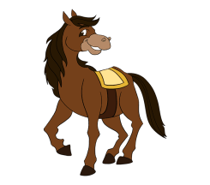Edwin’s unequivocally equine;
A neigh is his chosen sound.
Though clip-clop, clip-clop can also be heard
When he deigns to trot around.

Carmella is clearly a canine,
As her teeth and her snout convey;
Chasing automobiles is her pleasure,
Scaring mailmen just makes her day.

Efrem’s a slimy amphibian;
He croaks to attract a mate.
His sticky tongue is remarkably long,
As insects discover, too late.

Roberta’s a reclusive reptile;
Her skin is scaly and cold.
She favors swamps and rivers and ponds
And can live to 100 years old.

Arthur’s an ardent arthropod;
To you, that’s an insect or bug.
He sports six legs and exoskeleton,
And may be hiding under your rug.

Belinda’s a boisterous bovine,
A cow who bellows her moo;
She shares her milk with her farmer, John;
At least she has, hitherto.

Alfie’s an affable arachnid;
He spins webs, which catch all his meals.
Unless you have spinnerets of your own,
You have no idea how that feels.

Meg’s a merry marsupial;
As a mother, she’s surely no slouch.
Hopping about all day long, down under,
A joey peeking out from her pouch.

Marva’s a marvelous larva;
That’s a bug not fully completed;
She may grow into a bee or a butterfly,
It’ll be a while, though; so do please be seated.

Nice meeting you!

Sendy’s saga
Based on a true story.
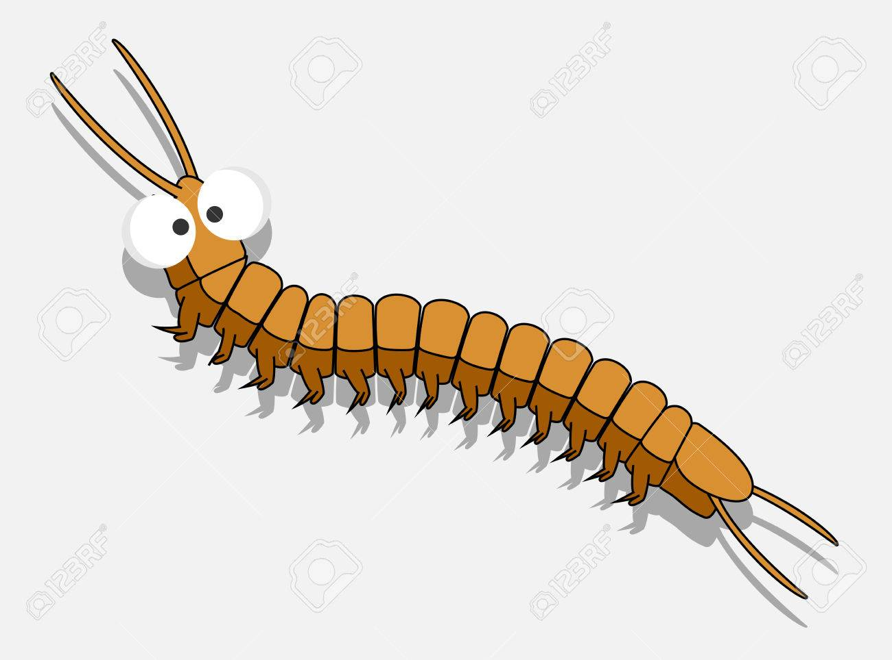

Yes, I’m a centipede. Sendy’s the name.

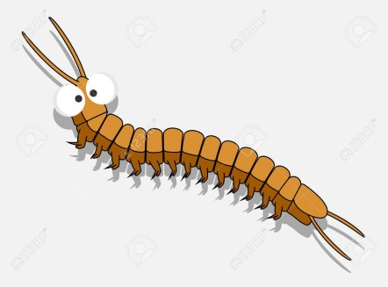

People think I’m ugly, even scary.

Well, I don’t think I’m ugly. And neither do other centipedes.
I’ve asked.
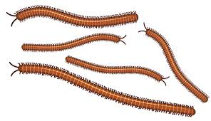

Scary? Well, to the bugs I eat, I imagine so, but you’re not a bug. I know, because bugs can’t read.

Yes, I know, they can’t write either, but let’s overlook that for now.

I can’t really harm a human. If you hold me in your bare hand, I might get scared myself (believe me, you humans are the scary ones!) and sting you. But the poison I have is designed to kill the bugs I eat. All it would do to a huge scary giant like you is hurt a little bit.

Still, people get all hot and bothered when they see me. I like the dark and they only see me when it’s light – like when they open a cabinet or shine a flashlight on me in some hidden place. Then I panic – I can’t help it! And I run as fast as I can. Which, with all my legs, is pretty fast. For some reason, my running for cover REALLY freaks people out.

About those legs. Despite my specie’s name – “centipede” means “100 legs” – it’s actually impossible for any of us to have 100 legs, because we always have an odd number of body segments and each body segment possesses two legs. So it’s either 98 legs or 102 legs, but never 100. What’s more, most of us don’t have either of those numbers of legs. We can have as few as 15 pairs and as many as 171. (I have 23 myself.)

I’ve never understood why our many legs seem to gross people out. You’re all fine with two-legged creatures like yourselves. And you seem fond of many four-legged ones, like dogs and cats. So people should really LOVE multi-legged animals like me.

But people don’t. It makes no sense. But what do I know? I’m just a centipede.

Anyway, most of us live our lives quietly and happily, munching on other insects until we grow old and die, or until some canine decides we’re dog food. Or until we have the misfortune of being discovered by some human who didn’t expect to find us and is grossed out instead of enamored of our inner beauty.

That’s what happened to me.

I was enjoying lapping up some moisture in a sink in a dark kitchen, when suddenly the lights came on. I tried to escape the sink but it was deep and I had trouble scaling its side.

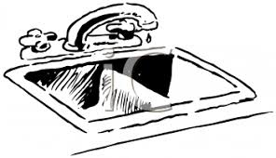

Next thing I know, a horrible human with hair coming out of his face – really scary! – was looking right at me. And SMILING!

It was, I thought, the end.

I remembered poor Sadie. She was discovered by a human in a cutlery drawer. After screaming – as if that would accomplish anything – she (the lady, not Sadie; centipedes can’t scream) took off her shoe and… and… oh, I can’t even think about what happened next. You can imagine.

And then there was Sam, who was dispatched with no respect whatsoever for his dignity by being deposited in a strange piece of furniture and flushed away to who knows where.

And so, I feared the worst. Would I be squashed… or flushed? All I know is that, before I could take another 23 steps, I was scooped up into a paper towel, held tight and immobilized. I wiggled my feet, but to no avail.

But my fear turned out to be unfounded. I felt that I was being moved somewhere and then heard a door slide open. I felt a rush of fresh air and then found myself IN the air, tossed there by the monster.

We bugs fall well. Our tiny weights and air resistance allow us to easily survive even a five-foot fall (the equivalent of a 100-foot one – no pun intended) for you human monsters.

And so I landed safely on an outdoor deck. Relieved beyond measure, I quickly scuttled out of sight.

And as soon as I was able to get to a computer, I got right to work writing this.
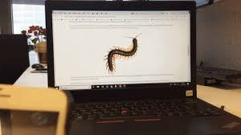
The End.

-----

